Name :-U.Siddhartha

Roll No:-2403A54122

Task1:-

Password Strength Validator:-

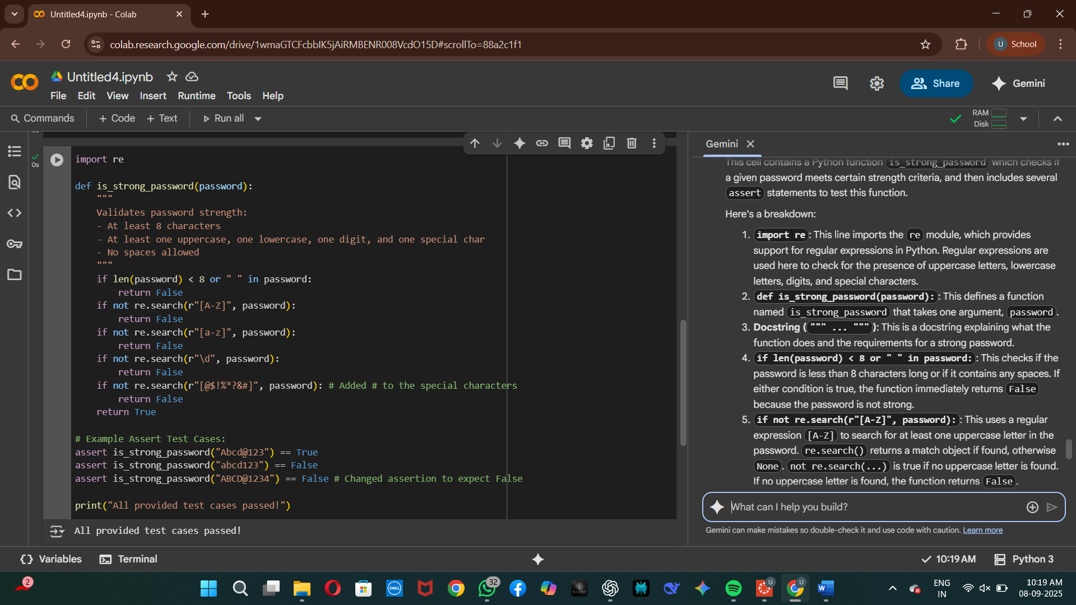

Task2:-

Number Classification With loops:-

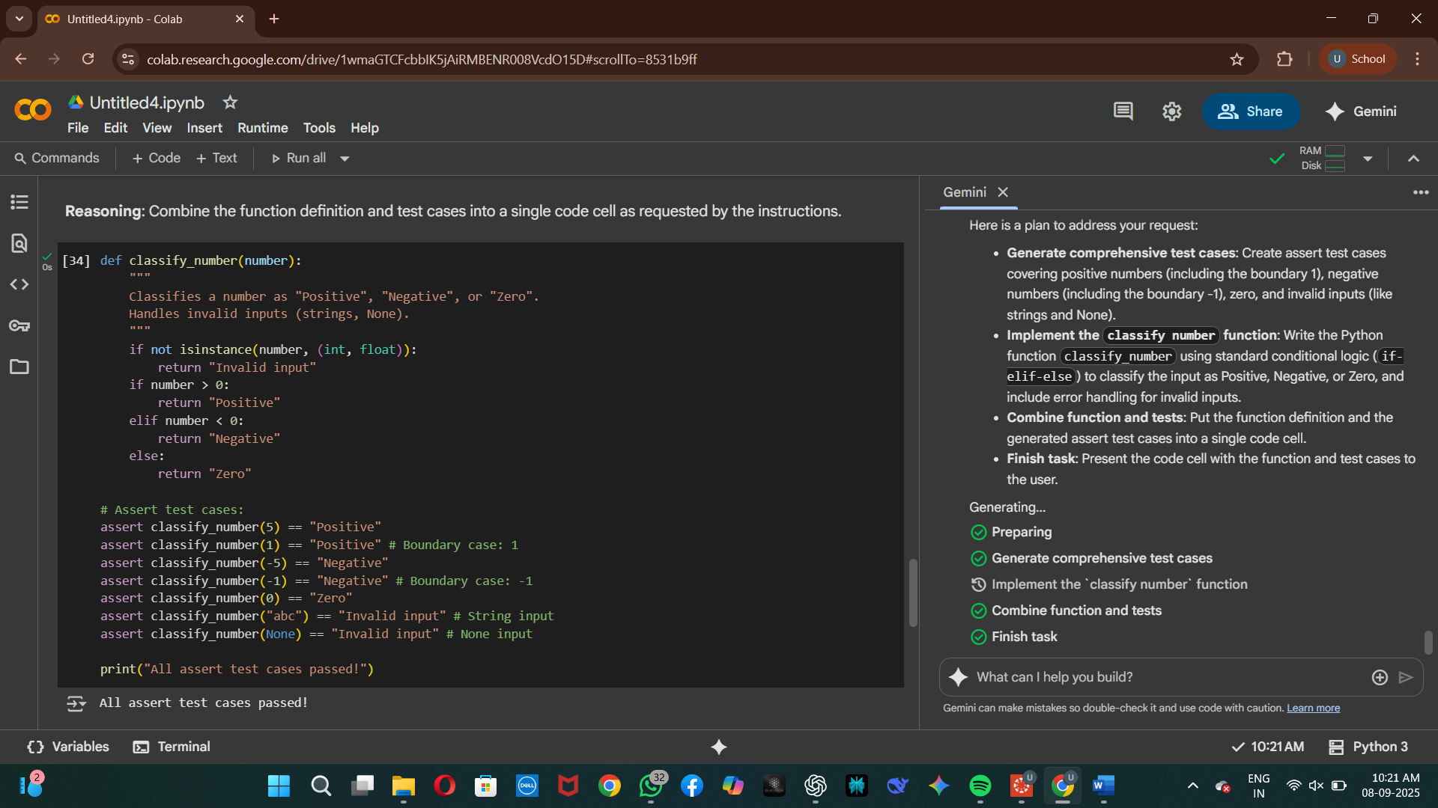

Task3:-

Anagram Cheker:-

Task4:-

Inventory class:-

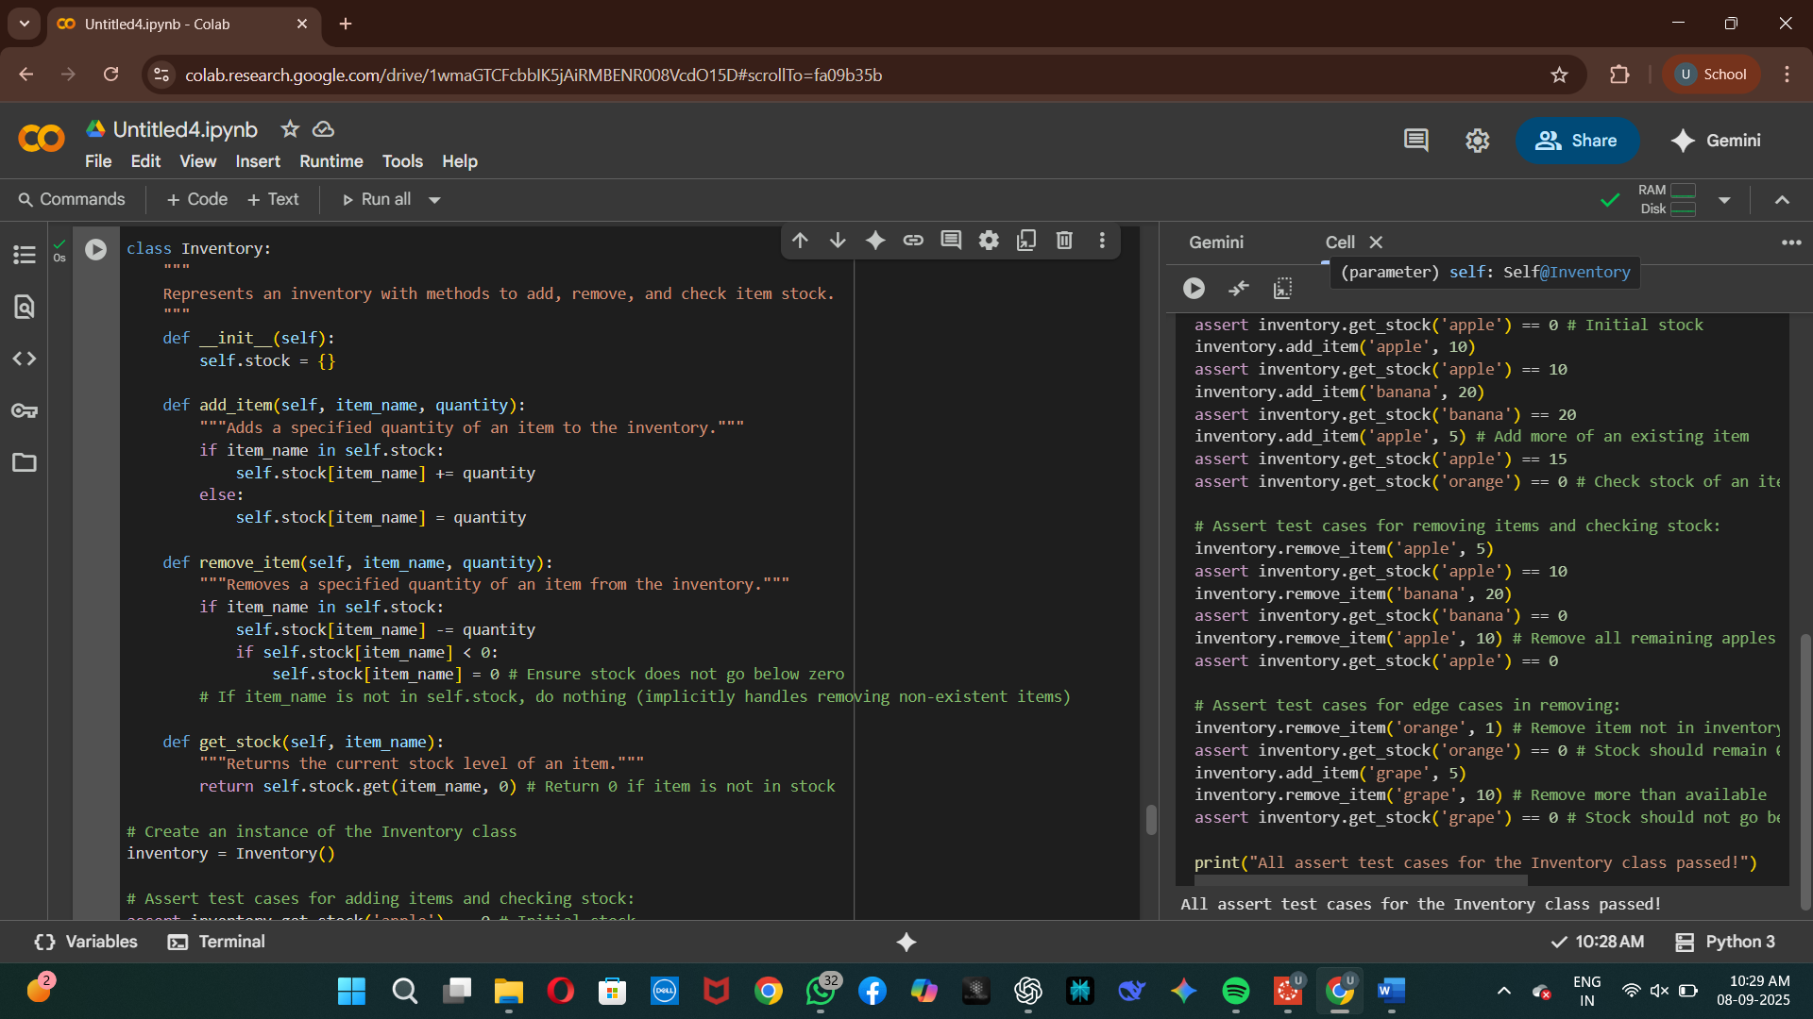

Task 5:-

Data Validating And Formatting:-

